

NOVAC TECHNOLOGY SOLUTIONS

User Manual

Document Version No.: 1.00

Revision History
Version No | Reason For Changes | Author | Approver
0.01 | Draft | Anurag Kumar
1.00 | Reviewed & Approved the User Manual | Anurag Kumar | NIJANTHAN PL

Table of Contents
1. Introduction 4

2. COC Authentication Report 4

Introduction

The document is prepared to understand the reports generated in ZIVA application. This document is being prepared in reference to,
- Guidelines, circulars, instructions and directions released from time to time by Philippines Insurance council.

Functional Overview

System should have provision to generate the IC reports in the ZIVA application. A separate menu is required as IC reports and under this reports following reports should listed.

COC Authentication Report
- System should generate the report for Individual Motor and Motor Fleet policies which having the COC details (COC Authentication Date and COC Number) based on the input parameter. System should have the provision to generate in both PDF and Excel format. System should not list the Cancelled policy.
- Note: Generated report should be tally of Summary report and Detailed Report.

Search the MIS Report Screen.

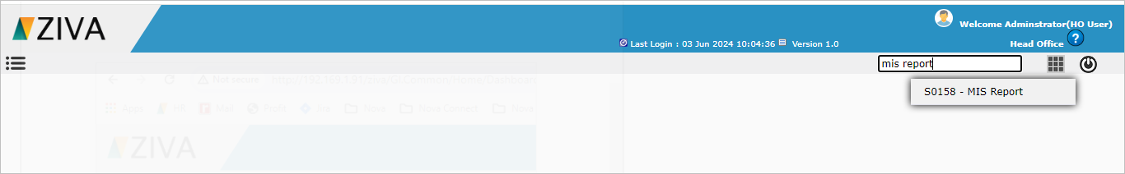

Click on the MIS Report Screen. System will display the Report details tab.

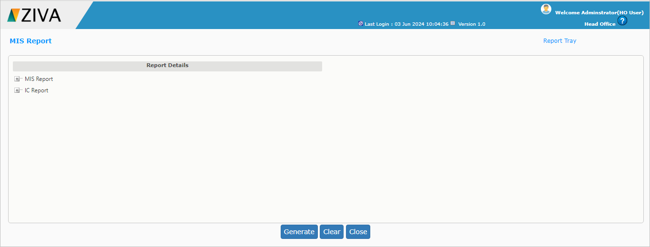

Select the COC Authentication report under the IC Report.

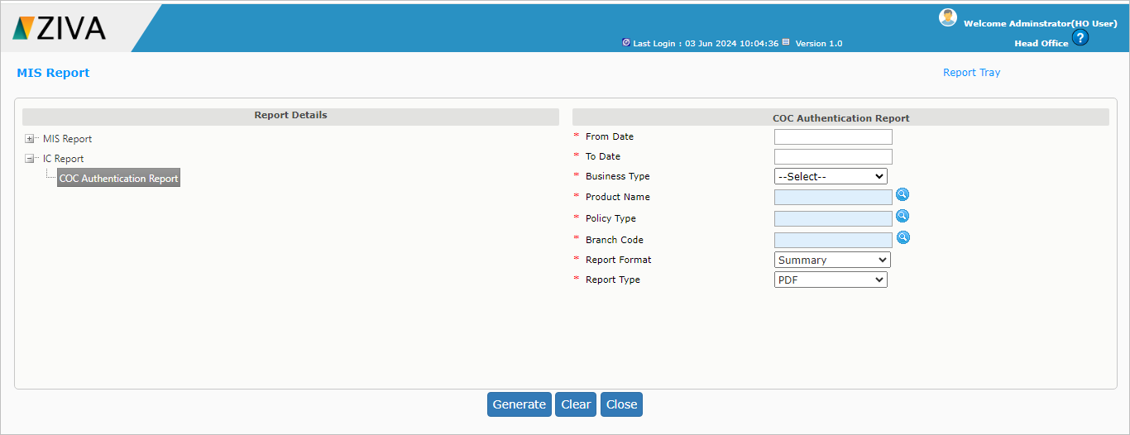

Enter all the details and click on Generate button.
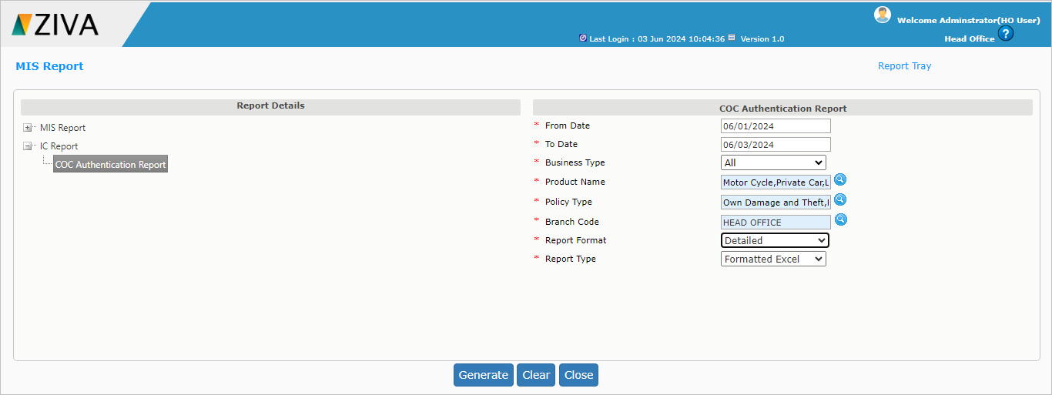

Once click on the Generate button system will display an alert message as “Report is being generated. You may now close this window. Go through Reports Tray to view the Report”.
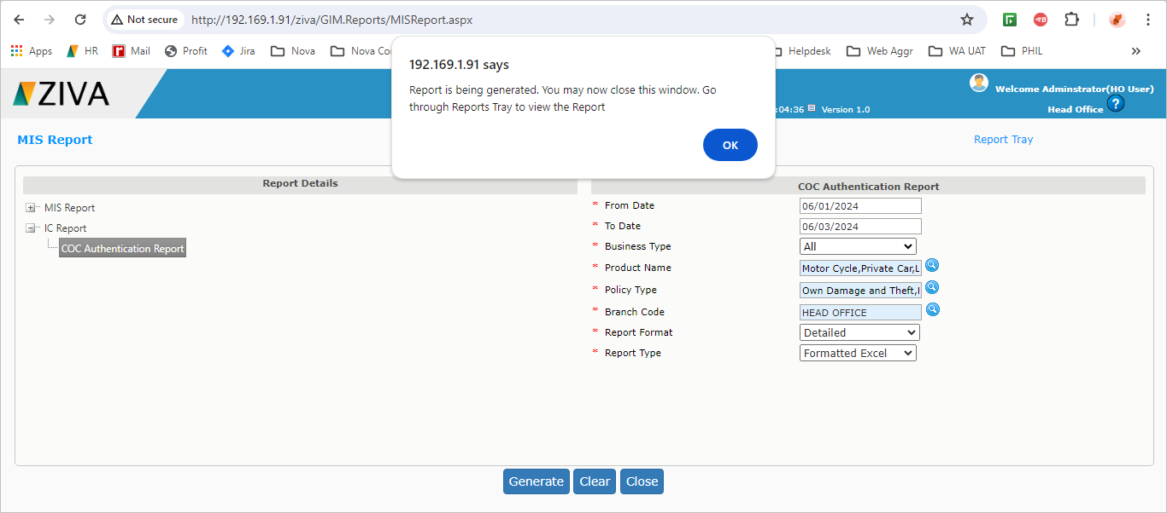

Click on the report tray link.

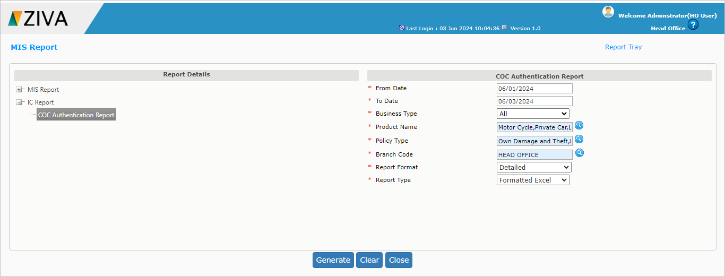

Once click on the report tray link, system will display the COC Authentication report.
Click on the view button to download the report.

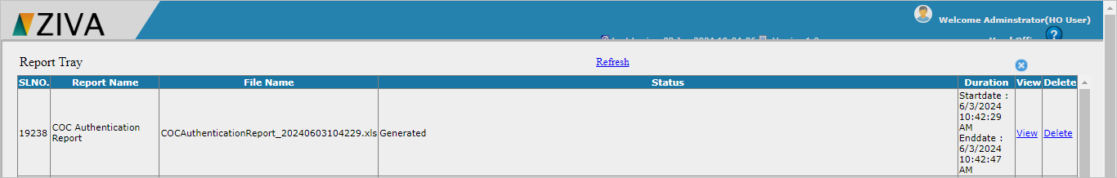

Click on X button to close the window.

